Oakland UNIVERSITY
CSI-1420-43271.202340-Intro to C Programming & Unix
Fall - 2023

Course Project: Information Retrieval System

- Due from November 27th. to December 4^{th.}
- Soft copy of the source code should be posted to Moodle.
- Output screen snapshots are also required.
- Word document explains the answers for each part and instructions for running the programs.
- Please write your name and student ID at the top of the word document

- Type each of the four text files below into text documents. Save the first one as d₁.txt, the second d₂.txt, the third d₃.txt, and the fourth d₄.txt.
- Convert each of these documents (text files d₁, d₂, d₃, d₄) into list of words/index terms/tokens.
- Eliminate Stop words.
- Eliminate Special characters.
- Sort the words in alphabetical order to make it easy to count the frequency of each word.
- Store the words or tokens in a file for example the list of words or tokens from d₁.txt is stored in a file called Tokenizedd₁.txt, and the same for the others.
- Compute frequency and weight.

Frequency = number of occurrences of the word in a document.
Weight = Frequency / Highest frequency of the word in the document.

Text file d₁:
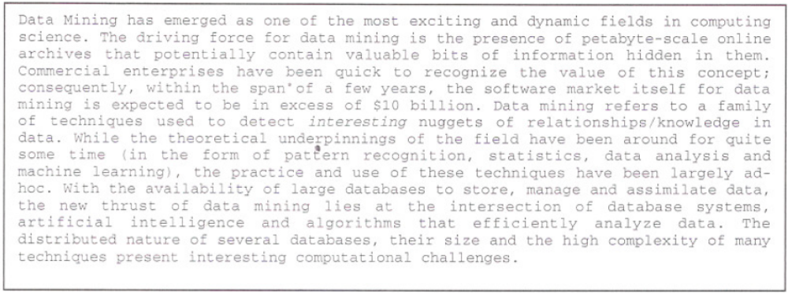

Text file d₂:
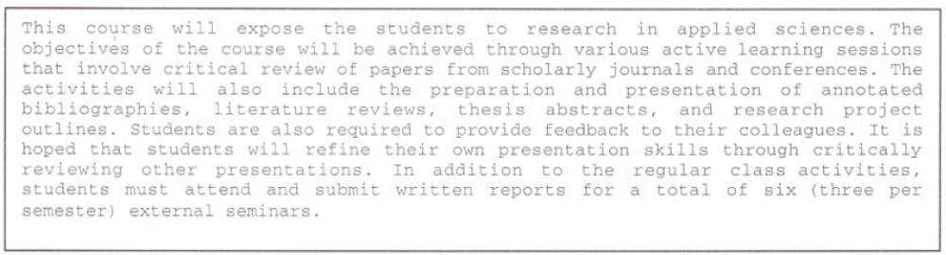

Text file d₃:

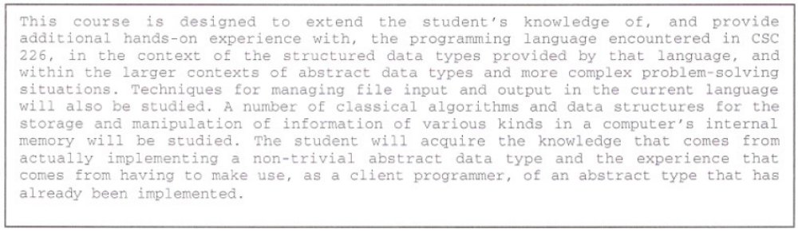
Text file d₄:

